Name ____________Alex Yeoh___________

PHY 1110 - Summer 2020 - Study Guide #8 - Work & Energy

1. Work
- is a (a) vector, or (b) scalar quantity with units of joule.
- is (a) a property of an object, (b) a measure of how much energy was transferred to or from an object by a force, (c) the same as force, or (d) the same as velocity.
- must (a) never be negative, (b) never be zero or negative, (c) never be positive, (d) be positive or zero only, or (e) be negative, zero, or positive.
2. Kinetic energy:
- is a (a) vector, or (b) scalar quantity with units of joule.
- is (a) a property of an object, (b) a measure of how much energy was transferred to or from an object by a force, (c) the same as force, or (d) the same as velocity.
- can (a) never be negative, (b) never be zero or negative, (c) never be positive, (d) be negative, or (e) be negative, zero, or positive.

2. A 10 kg mass slides across a horizontal, polished, wood gym floor (μ_{k} = 0.1) and comes to rest. As the mass crosses a blue line on the floor, it has a speed of 5.0 m/s. It comes to rest after sliding "Δx" meters beyond the blue line.

- Draw a free body diagram of the mass showing all three external forces acting on it: the weight, the normal force, and the force of kinetic friction.

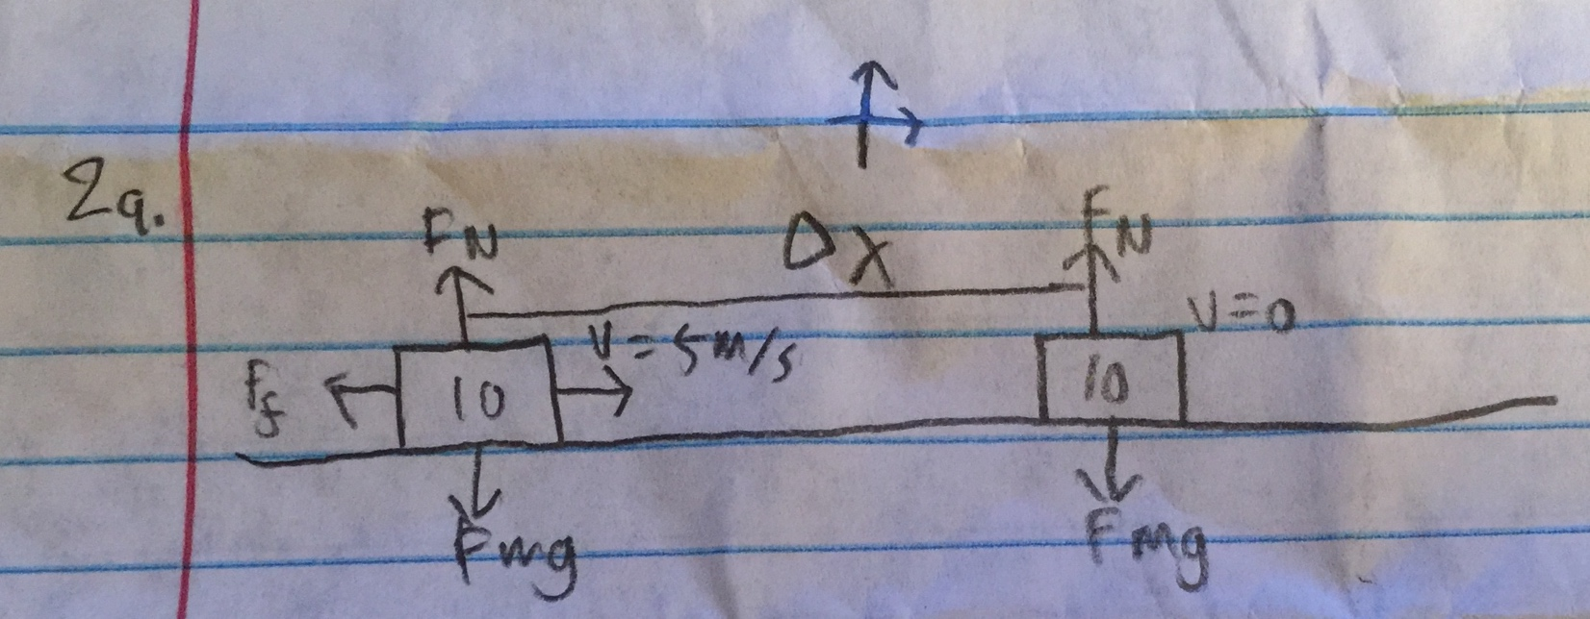

- Find the work done by each of the external forces and the net work done by all external forces as the mass slides from the blue line until it stops. (You cannot find a numerical value for the work done by the force of friction because "Δx" is still unknown. Just write the formula for now. You will find "Δx" in part d using energy methods.)

W_{N}=N(∆x)cos(90)=0
W_{mg}=mg(∆x)cos(90)=0
W_{f}=f(∆x)cos(180)=-μN∆x
W_{net}=∆KE=KE_{f}-KE_{i}=-μmg∆x

c) Find the initial and final kinetic energies of the sliding mass and the change in the kinetic energy (KE_{f} - KE_{i}).

KE_{f}=.5(10)(0²)=0J
KE_{i}=.5(10)(5²)=125J
∆KE=-125J

d) Use the work-energy theorem to find the distance "Δx" the mass slides before coming to
rest.

-(0.1)(10)(9.8)∆x=-125
∆x=12.76m

3. Some time after you park your 950 kg auto with the gears in neutral and without the brake set, you see it rolling along a horizontal section of your driveway. You stop it in 12 m by pushing against the front with a force of 125 N directed 15° below the horizontal. The frictional force acting on your auto is equivalent to sliding friction with μ_{k} = 0.07.
a) Make a free body diagram showing all four external forces acting on your auto.

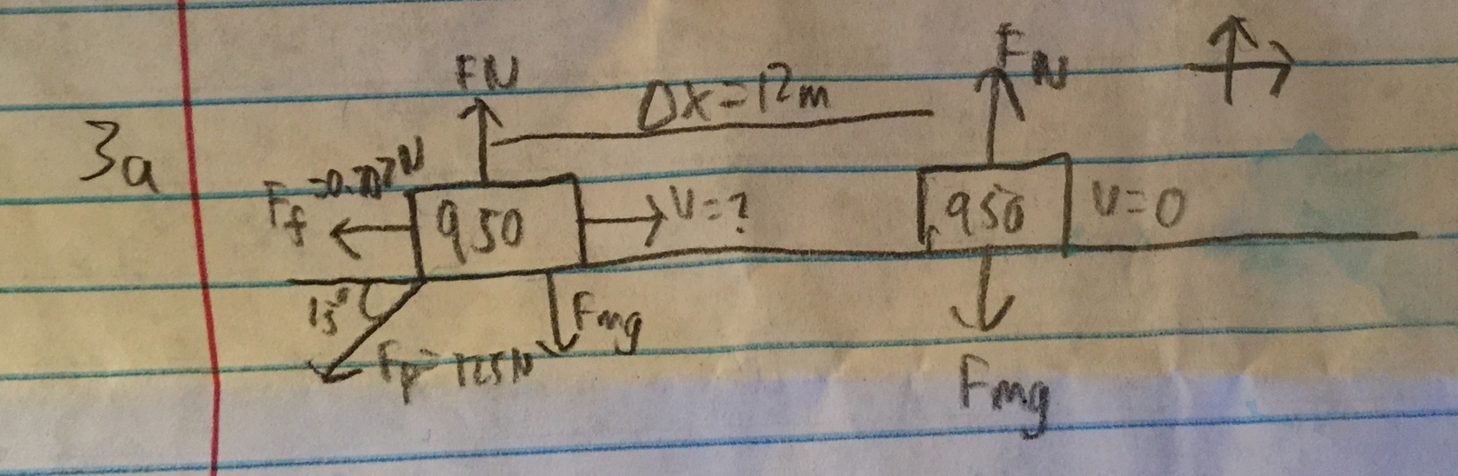

b) Calculate the normal force.

F_{N}=mg+F_{py}=950(9.8)+125sin(15)=9342.4N

- Calculate the work done by each of the four forces on your auto as it comes to rest.

W_{mg} = 0 (perpendicular to movement)

W_{N} = 0 (perpendicular to movement)

W_{p} = Fdcos(180+15)=-125(12)cos(15)=-1449N

W_{f} = Fdcos(180)=-μ_{k}mg(∆x)=-0.07(950)9.8(12)=-7848N

W_{net} = -1449-7848=-9297N

- Use the work-energy theorem to find the speed of the auto when you foolishly stepped in front it and pushed against it.

-.5mv²=-9297
V=sqrt(2*9297/950)=4.42m/s

